UAT Plan

for

[Grow]

Index

1. Scope 3

1.1. Objectives and business requirements 3

1.2. Scope 3

2. Testing team 4

3. Environmental requirements 5

3.1. Hardware requirements 5

3.2. Software requirements 5

4. Test Scripts 1

# Scope

## Objectives and business requirements

In this section, outline the business requirements. In other words:

The goal is to create a functional application to better help students engage in studying. The application is to include a timer, achievements and a planner.

*Example:*

*The goal of this user acceptance test is to ensure all the features of a website aimed at helping young people understand mental health work as designed.*

## Scope

In this section, outline the scope. This means:

* What is the pain point we’re trying to fix?
* What are we testing exactly, and what are we not testing?

The landing page of the application is simplified and easy to access and all menu (buttons) are functional.

For this UAT test, we’d like to test:

* Does the page load correctly
* Does the drop down menu work
* Does pulling data from backend database work
* Is notification working properly
* Does the pause and unpause work properly

For the UAT test, we are not testing:

* Loading Times
* How useful the tips are
* How many tips there are

*Example:*

*The collision detection algorithm has been refined to respond earlier and bring the robot to halt in a more controlled manner*

*For this UAT test, we’d like to test:*

* *Does the collision detection system identify solid objects*
* *Does the collision detection system begin responding earlier*
* *Does the collision detection system visual outputs work*

*For the UAT test, we are not testing:*

* *Other vehicle response mechanisms*
* *Does the collision response mechanism respond to mobile, irregular or transparent objects*

## System Diagrams

In this section, paste any drawings or diagrams that help the UAT team understand the program being tested. With each drawing include a brief explanation of how the drawing represents the application or system being tested.

*Example:*

*Storyboards, wireframes, flowcharts, schematics, pictorials, mood-boards, etc.*

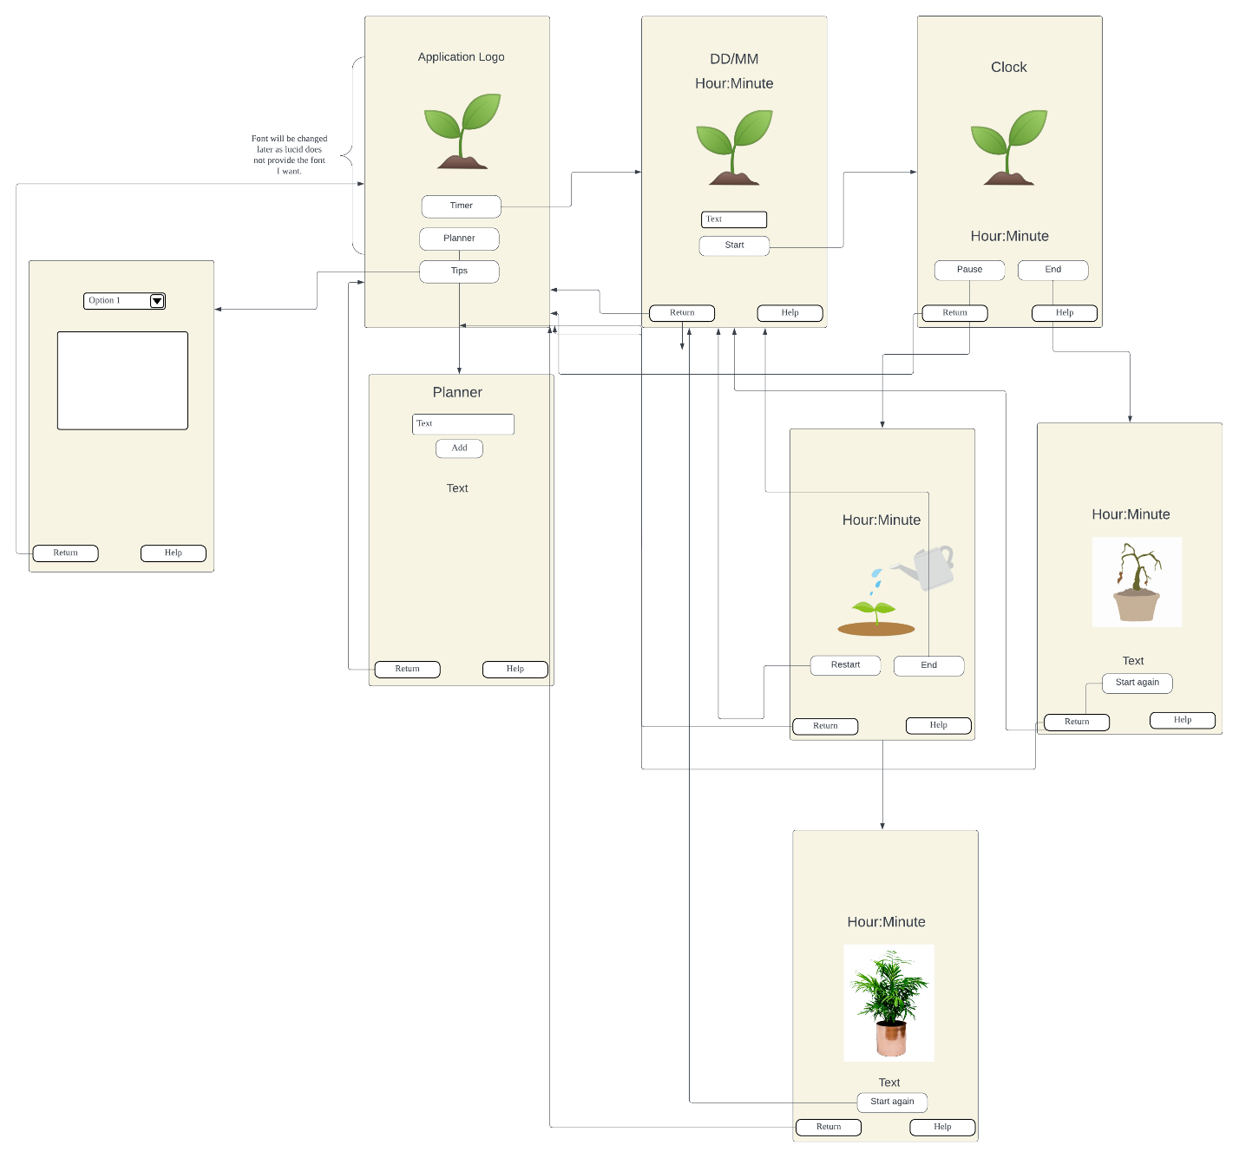

# Testing team

In this section, list out members of your QA team and what their roles will be during UAT.

|  |  |
| --- | --- |
| **Name** | **Responsibilities** |
| Amber | UAT Coordinator |
| Ria | Tester for page |
|  |  |
|  |  |
|  |  |

*Example:*

|  |  |
| --- | --- |
| ***Name*** | ***Responsibilities*** |
| *Robert K. Wright* | *UAT Coordinator - handles communication between end users and QA team* |
| *Johannes Creusen* | *Design test cases for the accounting team* |
| *Stefan Kottila* | *Design test cases for the management team* |
| *Roxanne Gilbert* | *Create test data and write UAT reports* |
| *Claudia Decker* | *Set up staging + usability test cases and reports* |

# Environmental requirements

## Hardware requirements

What hardware has the solution been designed for and should be tested on.

If that is the case, outline the minimal and recommended requirements so the QA team can verify that the software runs on the testers’ machines.

Any Laptop/Computer that can access the internet and google.

Any mobile device that can access the internet and google.

*Example:*

* *Lenovo Desktop PC*
  + *Windows 10.*
  + *Intel I5 processor.*
  + *256gb SSD.*
  + *8 GB of RAM.*
  + *Intel GPU.*
  + *Ethernet NIC.*
  + *LED 1080p Monitor with HDMI connection.*
* *Google Pixel 5 - Mobile Phone*
  + *Android 11.*
  + *Qualcomm SM7250 Snapdragon.*
  + *1080 x 2340 pixels, 19.5:9 ratio.*
  + *4g NIC*

## Software requirements

If any extra software or dependencies must be downloaded and installed, list them here.

* Laptop/Computer
  + Google Chrome
  + Safari (if APPLE)
* Mobile Devices
  + Google Chrome
  + Safari (if APPLE)

NOTE: Notification does not work on mobile safari

*Example:*

* *Lenovo Desktop PC*
  + *Google Chrome.*
  + *Microsoft Edge.*
  + *Mozilla Firefox.*
  + *Mozilla Firefox.*
* *Android Mobile Phone - Pixel 5*
  + *Google Chrome.*

## Network requirements

Some software (design, video editing…) can be demanding on hardware specifications.

If that is the case, outline the minimal and recommended requirements so the QA team can verify that the software runs on the testers’ machines.

* Laptop
  + Access to Home Network
* Mobile
  + 4G or 5G network

*Example:*

* *Lenovo Desktop PC*
  + *NBN Fibe to the Node network.*
* *Android Mobile Phone - Pixel 5*
  + *Telstra 4g network.*

# Test Scripts

This section is more important than it seems—it is crucial that both the QA team and the testers know what features must be tested, especially if you’re testing a lot at once.

**Study Tip Page – 0.3**

|  |  |  |  |  |
| --- | --- | --- | --- | --- |
| **Test** | **Describe the feature being tested** | **Describe the user input or test data** | **Describe the pass criteria** |  |
| 1.0 | If page loads correctly | 1. User presses study tips button | 1. Users sees a dropdown menu 2. User sees “Study Tips” at the top 3. User sees Return and Help button | Tester name: Ria   |  |  | | --- | --- | | · | PASS | |  | FAIL |   Observations:   * After pressing the ‘Study Tips’ button from the home page,  the dropdown menu is aligned directly underneath the title. * The title ‘Study Tips’ is at the top of the screen * The buttons ‘Return’ and ‘Help’ are formatted well and are at the bottom of the screen. |
| 1.1 | If drop down works correctly | 1. User clicks drop down menu | 1. Users sees three options “Taking Breaks”, “Organising Workload” and Concentration | Tester name: Ria   |  |  | | --- | --- | |  | PASS | |  | FAIL |   Observations:   * After pressing the Dropdown menu the three options can be seen |

**Study Tip Database – 0.3.1**

|  |  |  |  |  |
| --- | --- | --- | --- | --- |
| **Test** | **Describe the feature being tested** | **Describe the user input or test data** | **Describe the pass criteria** |  |
| 1.0 | If selecting “Taking Breaks” shows the correct tip | 1. User picks the “Taking Break” option in dropdown | 1. User sees a white box with “Taking Breaks” as its title and a short tip 2. No other boxes shows up | Tester name: Ria   |  |  | | --- | --- | |  | PASS | |  | FAIL |   Observations:   * After pressing the option, a white box with the title ‘Taking Breaks’ is seen at the top of the screen * The body text containing the tip is underneath the title. * The white box is formatted at the top of the page, directly underneath the dropdown menu * No other boxes can be seen |
| 1.1 | If selecting “Concentration” shows the correct tip | 1, User picks the “Taking Break” option in dropdown | 1. User sees a white box with “Concentration” as its title and a short tip 2. No other boxes shows up | Tester name: Ria   |  |  | | --- | --- | |  | PASS | |  | FAIL |   Observations:   * After pressing the option for ‘Concentration’, a white box centred at the middle of the screen can be seen * The title ‘Concentration’ is placed above the body text * No other boxes can be seen |
| 1.2 | If selecting “Organising Workload” shows the correct tip | 1, User picks the “Organising Workload” option in dropdown | 1. User sees a white box with “Organising Workload” as its title and a short tip 2. No other boxes shows up | Tester name: Ria   |  |  | | --- | --- | |  | PASS | |  | FAIL |   Observations:   * After pressing the option for ‘Organising Workload’, A white box containing the information can be seen * The title ‘Organising Workload is formatted well alongside the body text and is formatted above the body text. * None of the other boxes can be seen |
| 1.3 | When selecting “Select a study tip” all tip boxes disappear | 1, User picks the “Select a study tip” option in dropdown | 1. Users sees only the dropdown selector and RETURN and HELP buttons | Tester name: Ria   |  |  | | --- | --- | |  | PASS | |  | FAIL |   Observations:   * When pressing the option ‘Select a Study Tip’, all the other boxes disappear and only the ‘Return’ and Help’ buttons can be seen. |

Bug Fixes **0.3.2**

|  |  |  |  |  |
| --- | --- | --- | --- | --- |
| **Test** | **Describe the feature being tested** | **Describe the user input or test data** | **Describe the pass criteria** |  |
| 3.1 | If Pause Button is working correctly | 1. User press pause button | 1. User sees pot image change 2. User sees countdown timer stop 3. User sees a break time end time 4. User gets a notification saying timer is paused | Tester name: Ria   |  |  | | --- | --- | |  | PASS | |  | FAIL |   Observations:   * The animation transition from the countdown timer to the ‘Pause’ screen works well. * The countdown timer stops and accurately shows the time when you press pause * The ‘Break Time End’ accurately presents the time 5 minutes after the user presses ‘Pause’. |
| 3.2 | If Unpause buttons is working correctly | 1. User press unpause button | 1. Users sees image change 2. User sees new “Study Time End:” 3. User sees “Growing…” 4. User sees countdown timer resume 5. User gets a notification saying timer is resumed | Tester name: Ria   |  |  | | --- | --- | |  | PASS | |  | FAIL |   Observations:   * The transition from the pause animation to the countdown timer animation changes well. * The new ‘Study Time End’ accurately depicts the changed time. * The text for ‘Growing’ does not show, instead the text ‘5 minutes break’ is carried over from the ‘Pause’ screen |
| 3.3.1 | Notification working | 1. User MUST enable notification 2. User enters VALID time 3. User press start 4. User waits | 1. When timer ends normally (not using end button) the user should see a notification when it ends 2. If not supported shows a not support at the beginning of timer application | Tester name: Ria   |  |  | | --- | --- | |  | PASS | |  | FAIL |   Observations:   * Since I am using an IOS device as well as Safari (which blocks notifications), A pop-up stating that notifications are not supported appears at the beginning of the timer application screen |
| 3.3.2 |  | 1. User MUST enable notification 2. User enters VALID time 3. User press pause 4. User waits | 1. Timer is paused notification should show up 2. If not supported shows a not support at the beginning of timer application | Tester name: Ria   |  |  | | --- | --- | |  | PASS | |  | FAIL |   Observations:   * Since I am using an IOS device as well as Safari (which blocks notifications), A pop-up stating that notifications are not supported appears at the beginning of the timer application screen |
| 3.3.3 |  | 1. User MUST enable notification 2. User enters VALID time 3. User press unpause 4. User waits | 1. Timer is resumed notification should show up 2. If not supported shows a not support at the beginning of timer application | Tester name: Ria   |  |  | | --- | --- | |  | PASS | |  | FAIL |   Observations:   * Since I am using an IOS device as well as Safari (which blocks notifications), A pop-up stating that notifications are not supported appears at the beginning of the timer application screen |

Tip: Write step-by-step, detailed but concise instructions on how to test the feature.